QUIZZ {1h00}

STUDENT FIRST NAME / LAST NAME: 

**WARNING**

**YOU NEED TO CHECK CAREFULLY STEP BY STEP THAT YOUR CODE WORKS**

**If you code does not work, you will get a 0 score**

**Exercise 1: (25 POINTS)**

|  |  |
| --- | --- |
| Objective | Pick up all diamonds |
| Maximum number of instructions | 10 |
| Allowed instructions | GO-UP GO-DOWN GO-LEFT GO-RIGHT PICK-UP  IF  REPEAT N-TIME WHILE |
| Allowed conditions | <HAS DIAMOND> |

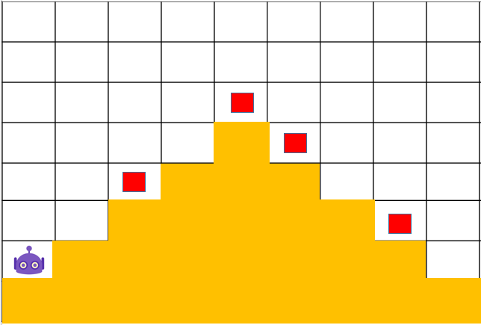

REPEAT<4>

IF <DIAMOND>

PICK-UP

GO-RIGHT

GO-UP

WHILE<HAS DIAMOND>

REPEAT<4>

GO-RIGHT

PICK-UP

IF <DIAMOND>

GO-DOWN

**Exercise 2: (25 POINTS)**

|  |  |
| --- | --- |
| Objective | Pick up all diamonds |
| Maximum number of instructions | 14 |
| Allowed instructions | GO-UP GO-DOWN GO-LEFT GO-RIGHT PICK-UP  IF  REPEAT N-TIME WHILE |
| Allowed conditions | <HAS DIAMOND> |

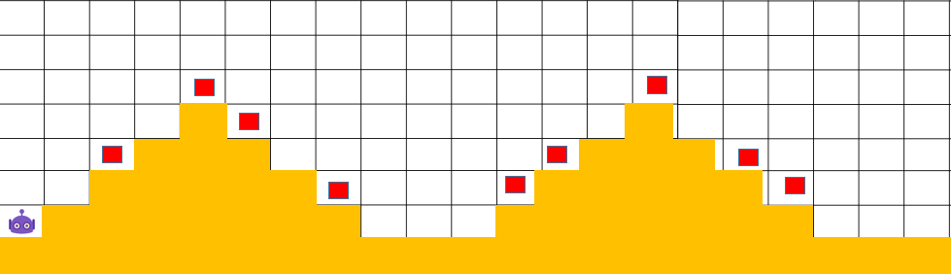

WHILE<HAS DIAMOND>

**Exercise 3: (25 POINTS)**

PICK-UP

IF<DIAMON>

REPEAT<2>

GO-RIGHT

GO-DOWN

GO-RIGHT

REPEAT<4>

REPEAT<4>

IF<DIAMON>

PICK-UP

GO-UP

GO-RIGHT

|  |  |
| --- | --- |
| Objective | Bring all carrots to their respective box |
| Maximum number of instructions | 13 |
| Allowed instructions | GO-UP GO-DOWN GO-LEFT GO-RIGHT PICK-UP DROP  IF  REPEAT N-TIME WHILE |
| Allowed conditions | <HAS CARROT> |

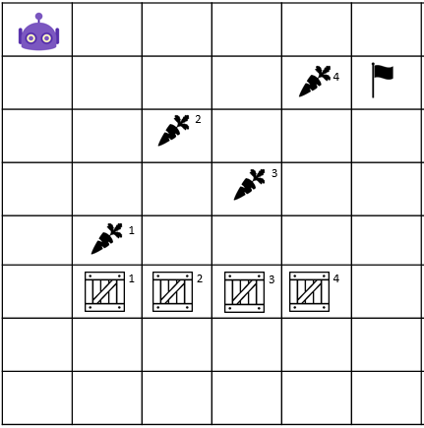

REPEAT<5>

GO-UP

GO-DOWN

PICK-UP

IF<HAS CARROT>

DROP

GO-RIGHT

WHILE<HAS CARROT>

REPEAT<5>

GO-RIGHT

**Exercise 4: (25 POINTS)**

* Flag**:** ទង់ជាតិ

|  |  |
| --- | --- |
| Objective | Bring all carrot to their respective box **and** stop at the flag!!  WARNING : you program must work for the 2 cases !!! |
| Maximum number of instructions | 10 |
| Allowed instructions | GO-UP GO-DOWN GO-LEFT GO-RIGHT PICK-UP DROP  IF  REPEAT N-TIME WHILE |
| Allowed conditions | <HAS CARROT>  <HAS FLAG>  <HAS **NO** FLAG> |

CASE 1 CASE 2

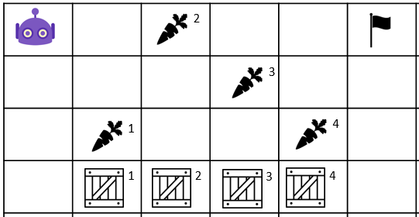 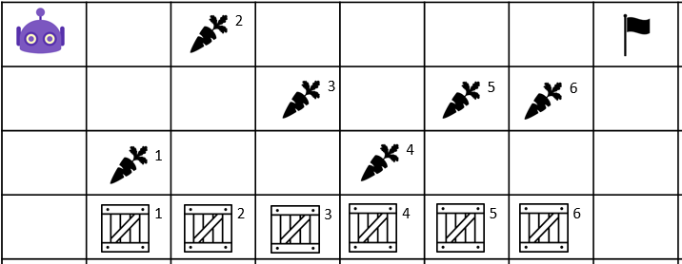

REPEAT<3>

GO-RIGHT

WHILE<HAS NO FLAG>

GO-RIGHT

GO-DOWN

IF<HAS CARROT>

PICK-UP

GO-UP

REPEAT<3>

DROP